# Introduction

## Artificial Intelligence

Artificial intelligence (AI) is defined as the ability to execute activities usually associated with intelligent beings on a digital computer or computer-controlled robot. The term is usually used to describe projects which consist of developing systems that try to replicate more or less the thinking and intellectual processes of humans, such as the ability to reason, discover meaning, generalize or learn from past experiences. Computers have come a long way since the early development of the digital computers in the 1940s, and it has been proven that computers are able to carry out complex tasks that humans have a hard time doing, such as discovering proofs for mathematical theorems or playing chess with great accuracy and proficiency. Despite the rapid advances in computer processing speed and memory capacity, computers are not able to match human intellectual flexibility over wider domains or in tasks that require creativity and everyday knowledge. Artificial intelligence is usually found in applications as diverse as medical diagnosis, image recognition, computer search engines and voice or handwriting recognition ( Copeland, 2020) . The difference between natural human intelligence and artificial intelligence can be seen in Figure .

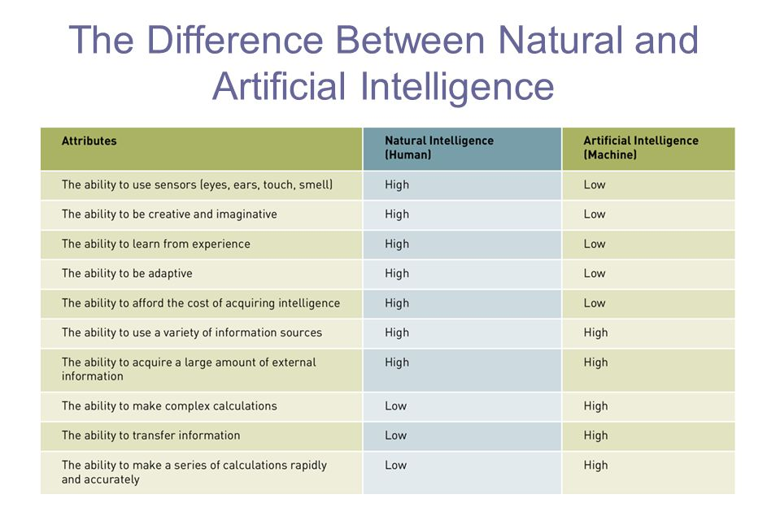

Figure 1: Difference between natural and artificial intelligence

Artificial Intelligence itself is quite general and high level as it covers any technique which enables computers to mimic human behaviour. To look deeper into AI, we have to take a closer look at its subsets which are machine learning and deep learning.

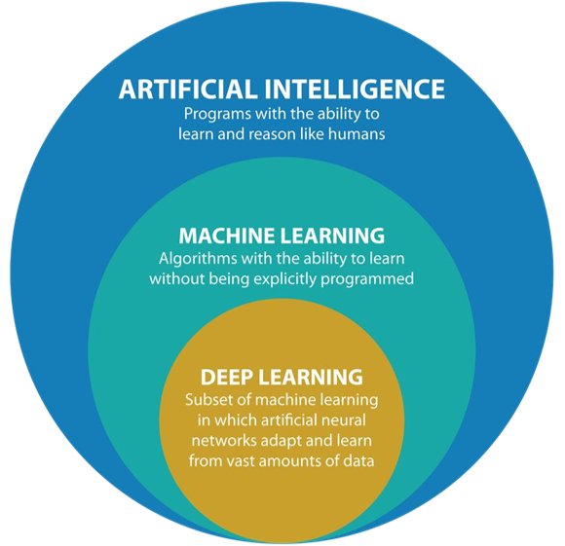

Figure 2: Differences between AI, ML and DL

# Searching

* To achieve goals or to maximize our utility we need to predict the result of our actions in the future.
* There are many sequences of actions with their own utility/ purpose
* We want to find the best possible sequence of actions to meet our goal

### Problem Formulation

* Initial state - e.g. chess position of each pieces
* Action: possible actions in current state - possible moves in the current chess position
* Transition model Result(x,a) = state that follows from applying action a in state x - e.g. ***Result(*** *X1(Queen at D1), A1( Queen at D1 → Queen at D2)* ***) = X2( Queen at D2)***
* Goal Test - e.g. Checkmate(x)
* Path cost
  + Sum of distances and number of actions executed
  + ***c(x, a, y)*** is the step cost, assumed to be over 0
  + Solution: a sequence of actions leading from the initial state to a goal state

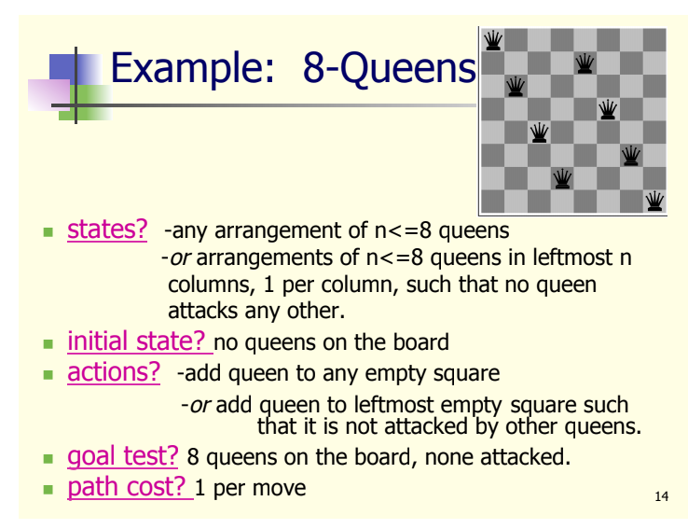

Figure : Example of problem formulation

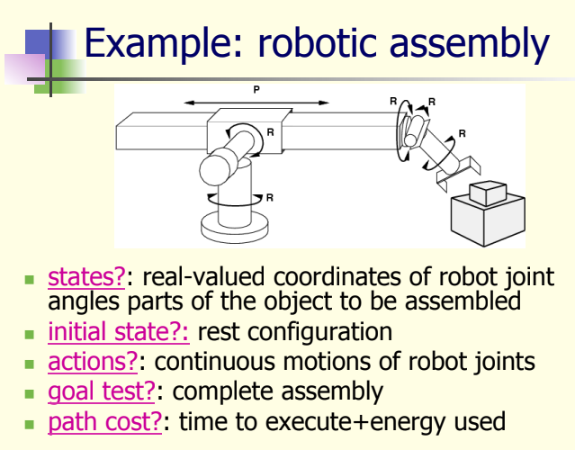

Figure : Example 2 of problem formulation

## Tree Search Algorithms

* Basic idea:
  + Exploration of state space by generating successors of already explored states
  + Every state is evaluated by asking, **is it a goal state?**
* State vs node
  + State: a representation of a physical configuration
  + Node: a data structure constituting part of a search tree containing info such as: state, parent node, action, path cost and depth
  + 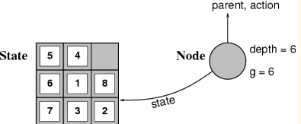
* Uninformed search strategies
  + No clue whether one non-goal state is better than any other. The search is blind. Unsure whether explorations likely to be fruitful
  + Types of blind strategies:
    - Breadth-first search
    - Uniform-cost search
    - Depth-first search
    - Iterative deepening search

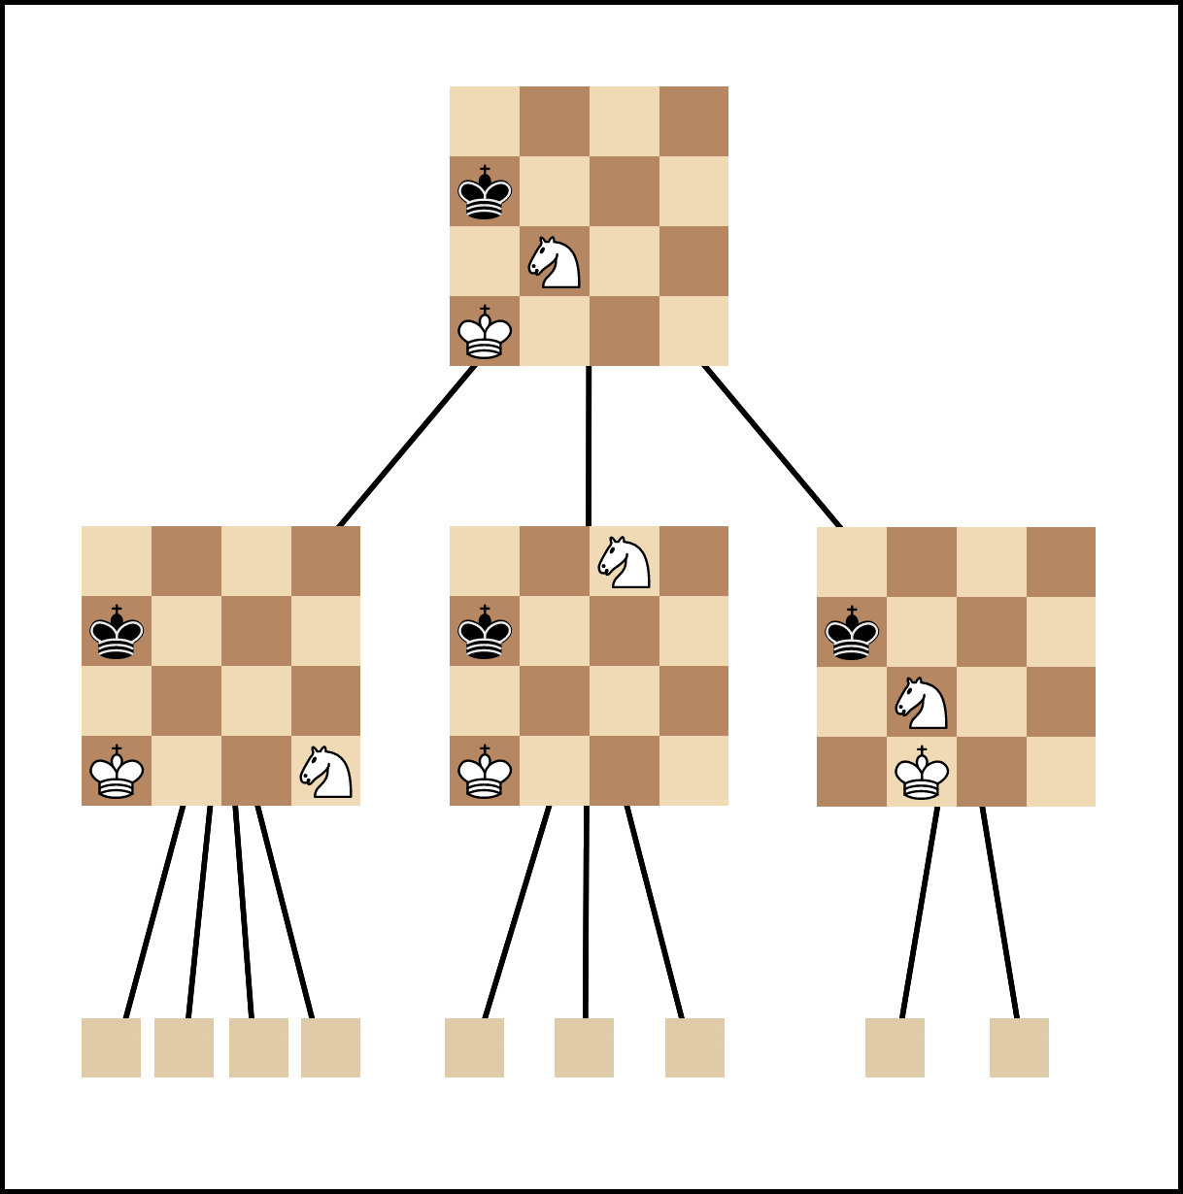

Figure : Example of Search Tree

## Game Searching

Since the beginning of the modern AI era, game -playing programs have been developed by AI researchers such as chess, checkers and others. The program must be able to control the sequence of moves made by one player, and also observe and make sense of moves made by the opponent. Opponent’s moves, especially human players, create a lot of uncertainty and all possible opponent’s moves must be covered by the program.

### Problem Formulation

* Initial State: Initial board position + which player’s move it is
* Operators: Legal moves a player can make
* Goal: Win the game

### Search Objective

* Find the sequence of player’s moves by maximizing the payoff
* Consider the opponent’s moves and their utility

### MinMax Algorithm

* To reduce the number of possible opponent moves, we can assume that the opponent moves rationally
* This algorithm determines the best move to counter the opponent’s move
* More suitable for a simple and deterministic games since the complexity is equals
* Impossible for larger games such as chess ( 35 operators, a game may have 50 or more moves)
* One way to solve this is to reduce the number of sub-trees by using estimates

### MinMax estimates

* Idea is to cut off the tree before the terminal state is reached to reduce demand of computational power
* Use imperfect estimate of minimax value at terminal node/ leaves by using evaluation function
* Evaluation functions:
  + Use Heuristic estimate of the value for a sub-tree
  + Give a value for each piece on the board, and the position of the pieces
  + Use these values to create a feature-based evaluation function
  + 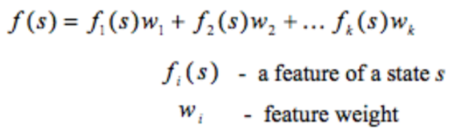
  + A restricted set of moves can be exempted under the cutoff level, which removes unwanted branching and improves the evaluation functions - e.g. in chess the computer tries to play for a better position or gain material advantages

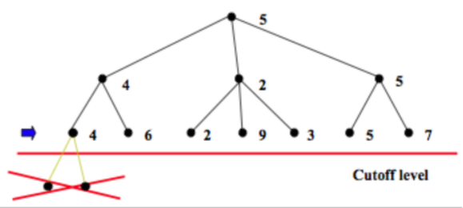

Figure : Moves before cutoff level are not considered to save computational power

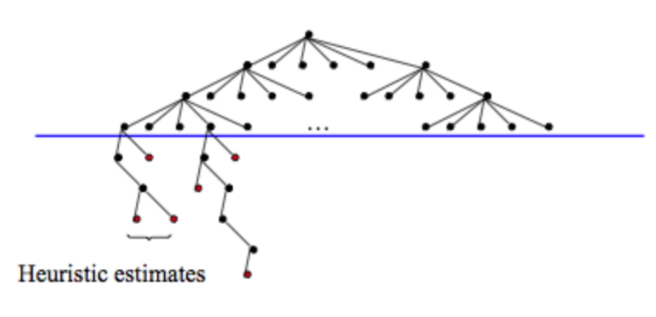

Figure : Moves that improve evaluation or able to continue branching ( computer makes good moves)

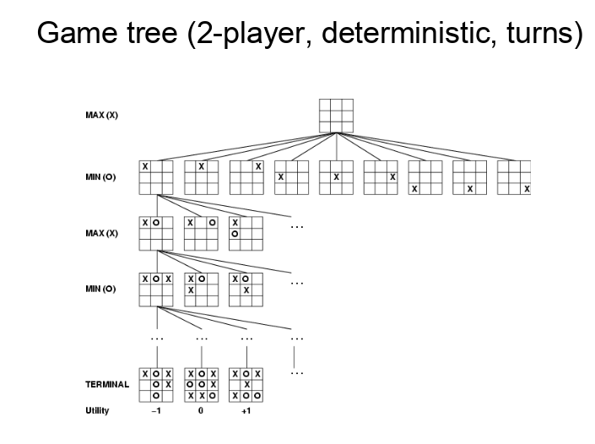

Figure : MinMax Algorithm example for Tic Tac Toe

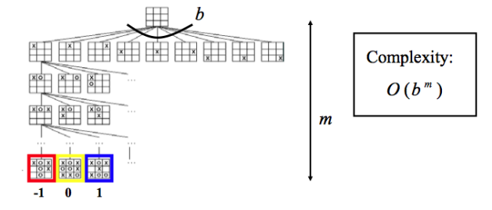

Figure: Complexity of MinMax Algorithm

## Machine learning

Machine learning is an implementation of artificial intelligence (AI) that gives systems the ability to automatically learn and develop from experience without being specifically programmed. Machine learning focuses on the creation of computer systems that can access data and use it to learn about themselves. Traditional programming methods rely on hardcoded rules, which step-by-step set out how to solve a problem. In comparison, a task is set for machine learning programmes, and a vast volume of data is provided to use as examples of how this task can be performed or from which patterns can be found. The machine then discovers how the intended output will better be obtained. It can be viewed as narrow AI: provided a particular collection of data to learn from, machine learning helps smart systems that are able to learn a specific purpose.

While still not approaching the human-level knowledge that is typically synonymous with the term AI, opposed to conventional programming approaches, the ability to learn from data increases the amount and complexity of tasks that machine learning systems can perform. Machine learning can execute complex functions such that the desired outputs cannot be generated based on human programmed step-by-step procedures. The learning dimension also produces applications that can be flexible and increase the accuracy of their outcomes once they are implemented ( Markoff, 2015).

Many individuals currently engage with machine learning-driven systems on a regular basis. In image recognition systems, such as those used to tag images on social media; in voice recognition systems, such as those used by automated personal assistants; and in recommendation systems, such as those used by online merchants(Markoff, 2015).

Machine learning still provides tremendous future promise in addition to these existing uses; more applications of machine learning are currently under implementation in a wide variety of areas, including healthcare, education, transport, and more. Machine learning may offer more detailed clinical diagnostics or tailored therapies, boost student learning by tailoring classroom practises, and support intelligent transport networks. Through taking lessons from large databases, it could also help research progress and drive operating efficiencies through a number of industries (Markoff, 2015).

Machine learning will improve efficiency, provide more efficient public services, and develop new goods or services customised to customer needs by increasing our capacity to derive information from ever-increasing data volumes. In doing so, however, concerns emerge about modern applications of data and the role of smart computing systems in society. Given the scale and growing pervasiveness of the possible advantages of this technology, now is the time to ensure that it is implemented in a manner that generates consumer trust and solves key questions or challenges. This is not only meant to manage the possible risks of machine learning, but also to ensure that the maximum spectrum of potential benefits are achieved (Markoff, 2015).

The three key branches of machine learning are supervised, unsupervised and reinforcement learning.

To forecast future events, supervised machine learning algorithms may apply what has been observed in the past to new data using labelled examples. The learning algorithm generates an inferred function to make assumptions about the output values beginning from the study of an established training dataset. After ample preparation, the device is able to provide targets with any new input. In order to adjust the model accordingly, the learning algorithm can also compare its output with the correct, expected output and identify errors (“expert.ai”, 2020).

In addition, where the data used for training is neither identified nor labelled, unsupervised machine learning algorithms are used. Unsupervised learning explores how systems can infer from unlabeled data a feature to explain a secret framework. The machine does not work out the correct output, but it examines the details and can draw data set inferences to explain hidden constructs from unlabeled data (“expert.ai”, 2020).

Reinforcement learning relies on learning from experience, which lies between learning that is unsupervised and supervised. The program communicates with its surroundings in a traditional reinforcement learning environment and is given a reward feature that it attempts to refine, just as the machine would be rewarded for winning a game. The agent's aim is to learn the ramifications of his choices, such as which moves were critical in winning a game, and to use this learning to discover strategies that increase its rewards.

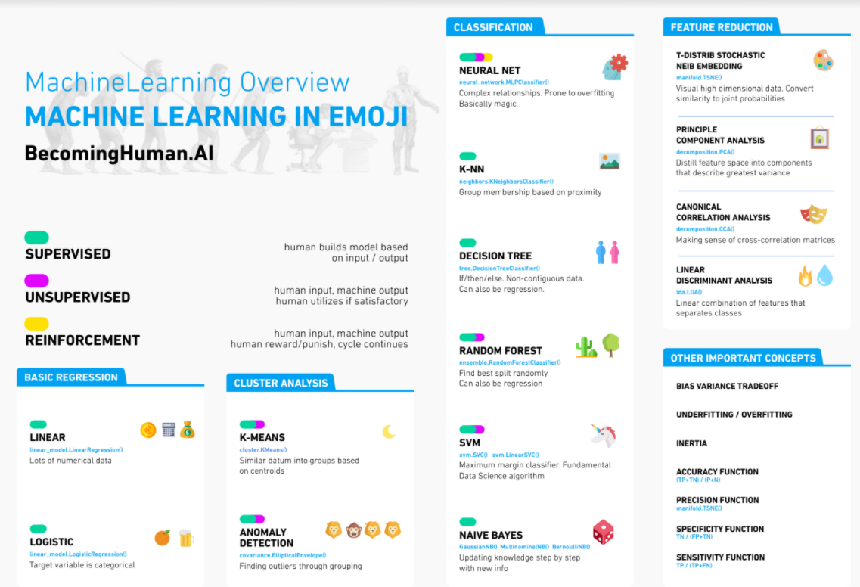

Figure : Summary of Machine Learning

## Deep Learning

Deep Learning is a subfield of machine learning and artificial intelligence concerned with algorithms inspired by the structure and function of the brain called artificial neural networks. These artificial neural networks are algorithms inspired by the human brain, and learn from large amounts of data. Just like how humans learn from past experiences, deep learning algorithms would perform a task repeatedly, each time tweaking parameters in the algorithm a little to improve the outcome. We refer to these algorithms as deep learning because the neural networks have various (deep) layers that enable learning. Any problem that requires thinking to solve is a problem that deep learning can learn to solve. However, to successfully create a deep learning neural network which produces good results, we have to collect huge amounts of data.

The amount of data we generate every day is astronomical - currently estimated at 2.6 quintillion bytes- and it’s the resource that makes deep learning possible. Since deep learning heavily relies on a ton of data to learn from, the increases in data creation in recent years is one of the reasons why deep learning capabilities have grown considerably. In addition to increase in data creation and collection, stronger computing power and also the growth of Artificial Intelligence as a Service benefitted deep learning too (Marr, 2018).

In general, Deep learning allows computers to solve complex problems even when using a data set that is very diverse, unstructured and interconnected. The more deep learning algorithms learn, the better they perform.

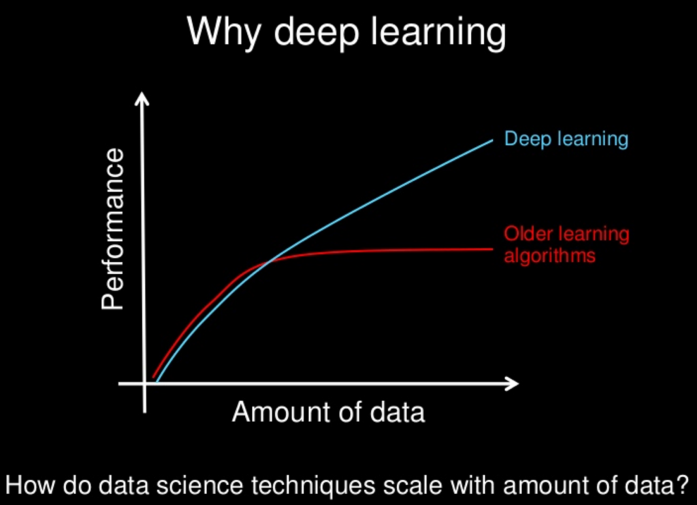

Figure : Deep Learning vs other older machine learning algorithms

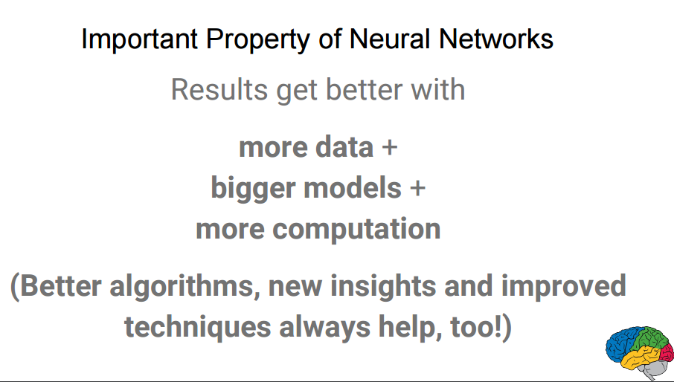

Figure : How deep learning improves

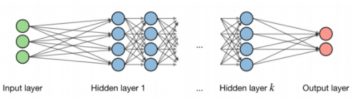

Figure : General concept of a neural network

## Recent Advancements in Machine Learning

Progress in AI is usually marked by the ability of computer systems to play and beat humans at different games. In the 1950s and 1960s, an IBM researcher named Arthur Samuel wrote a machine learning program that could play checkers. The program works by using a search-tree to calculate all the possible moves and evaluate the board position at the same time. The machine is able to understand good and bad moves through playing multiple games, but it never achieved expert-level play.

In 1997, Deep Blue, also built by a team of researchers in IBM, became the first computer to beat world chess champion Garry Kasparov. It also uses the same kind of algorithm, but with the increased computing power at that time, it is able to calculate 200 million moves per second and pick the best one.

In 2011 IBM’s Watson also beat two US quiz show champions.

In all these feats, the computer is fed with encoded human knowledge and rules on how to play the game and what moves to use in various situations and uses search or decision-tree methods to select an appropriate response. However these systems are limited in their scalability and transferability, a chess playing system cannot play other games, and these types of systems cannot be used effectively at games which use more intuition than following a set of rules, such as the ancient Chinese game of Go.

The game Go has simple rules but it is incredibly complex for the machine learning system to get the best move because of the huge number of potential moves. Expert Go players rely more on intuition and instinct to play the game rather than a rigid set of instructions. In 2016, Google DeepMind AlphaGo successfully conquered this challenge by using a different approach: using stochastic searches and deep neural networks, they trained AlphaGo on 30 million moves from actual games played by human players. AlphaGo also learned from reinforcement learning by playing against itself for thousands of games. In 2016, AlphaGo played five games against Lee Sedol, who is the world’s top Go player for over a decade; it won 4 games out of the 5. The critical moves played by AlphaGo had only a 1 in 10,000 chance of being played by an actual human being, which shows how impressive AlphaGo tackled this complex problem. Many Go experts were surprised and in awe when witnessing the match. This match marked another milestone in the development of machine learning.

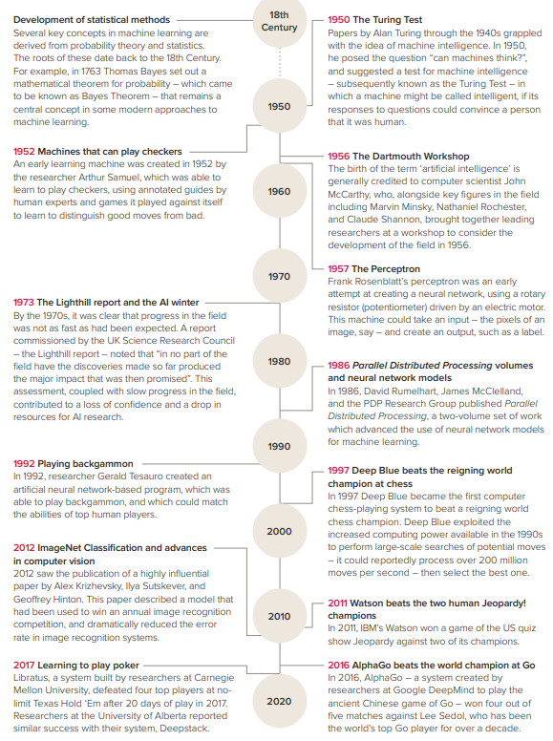

Figure : Developments in machine learning and AI

## Limitations of existing machine learning approaches

* Some machine learning methods focus on the accessibility of vast amounts of labelled training data, which can be resource-intensive and time-consuming to construct or curate.
* The creation of structures with contextual comprehension of a problem, or "common sense," is challenging. If our knowledge fails, people fall back on common sense and sometimes take precautions that, while not ideal, are unlikely to do serious harm. This behaviour is not described or encoded by current machine learning systems, meaning that when they fail, they can fail in a severe or unstable way.
* Humans are excellent at moving thoughts and ideas from one issue domain to another. This, even with the new machine learning methods, remains difficult for computers.
* Interpretation of data is also a challenge. The data and knowledge encoded in a machine learning system is needed to be in a form that can be easily understood by humans.
* The physical world has many limits that we know from natural laws (such as physics) or from mathematical laws such as logic. Adding these restrictions for machine learning techniques is not easy.
* Understanding the intent of humans is highly complex, it requires a sophisticated understanding of us. Currently we only have understanding of humans that are restricted to certain domains.

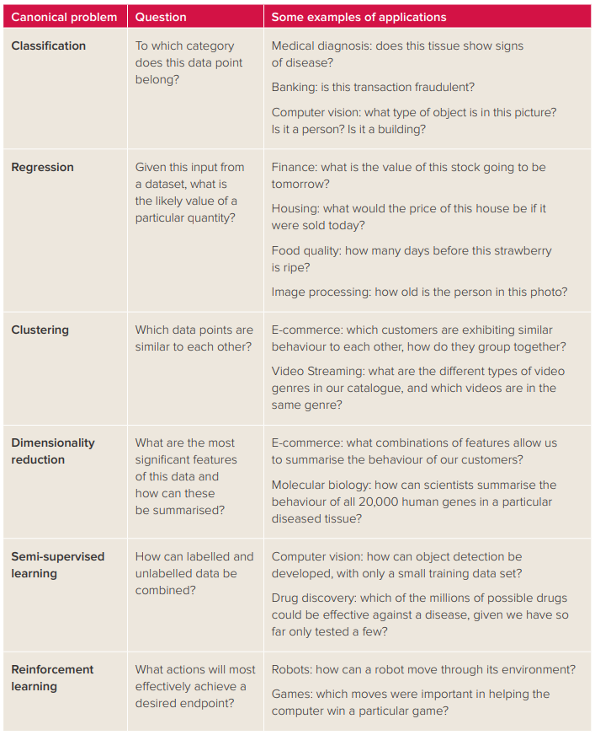

Table 1: Canonical problems in machine learning

# Future and Potential Application of Machine Learning

While machine learning is already supporting and a crucial part of a range of systems in common use these days, there is potential for more.

### Healthcare

Machine learning is able to deliver more detailed and accurate diagnosis and more efficient healthcare services through advanced research and analysis that enhances decision-making.

One example of this feature comes from the detection of breast cancer. Diagnosis of breast cancer usually requires an examination of a tissue sample by pathologists, in which physicians search for some characteristics that suggest the existence or extent of the disorder. By identifying and using characteristics of the image that were predictive that had not previously been used in pathology evaluations, a machine learning algorithm trained on tissue images was able to obtain greater precision than pathologists. In doing so, the scheme was able to help doctors determine the prognosis of a condition more reliably (Corrado, 2017).

Other machine learning methods still exist that can provide doctors with decision-making assistance. The 'Watson' of IBM, for instance, uses machine learning in several ways. One of them is the natural language processing of machine learning that helps machines to interpret written or verbal knowledge-used by Watson to extract information from the large array of research papers and case studies published and use this information to suggest alternatives for treatment.

Tasks such as the extraction of characteristics from complex data sets such as images, ECGs and other tracking devices; or the identification of health or disease trends in people from medical records, wearable devices; or the integration of information from various sources to make diagnosis and care decisions are all well suited to machine learning approaches (Corrado, 2017).

### Education

Machine learning can support new ways of providing teaching materials, especially in the online world, and can help teachers develop customised learning plans or execute certain routine tasks for specific students.

Applications that use machine learning to allow teachers to grade student papers more effectively are being created. One such app, Gradescope, scans the responses of students to questions and groups them according to the responses given. The instructor will either check these categories, validate that the method has properly assigned students to groups, or manually modify who is assigned to which category. Marks will be awarded accordingly once the instructor agrees to the suggested groupings. This input helps the system to enhance its efficiency in the future.

Machine learning is already used in online education systems; it is used for the study of student inputs, grading assessments or other computer-based tasks in Massive Open Online Courses (MOOCs) and in certain computer vision features. In this way, the use of artificial learning helps course organisers to help a vast number of students and devote human resources to less repetitive tasks.

In the future machine learning could help track student understanding and make recommendations for future learning activities personalised to individual students to bring the best out of each student.

### Transport and Logistics

Autonomous vehicles need to be able to identify a number of environmental features to function safely on the roads, including: barriers, road signs, pedestrians, and other vehicles. The range and variability of these features ensures that hard-coded guidelines defining what the vehicle is going to come into contact with and how it can react in various circumstances cannot be established. Machine learning helps the vehicle to adjust and respond appropriately to a variety of features. For example, Amazon successfully delivered using delivery drones in 2016.

Machine learning also can be used to design and develop intelligent transport systems.

For example, algorithms might study historical data on traffic patterns in a city, use this data to refine the system and predict how it will respond to various stresses at different times of day. In order to minimise congestion, these insights will then be used, with corresponding consequences for lowering greenhouse emissions. It will also be feasible, with sufficient knowledge, to analyse traffic flows in real time and make complex changes to enhance traffic flow.

Machine learning may also play a part in the optimisation of logistics and related systems. This can be achieved by recommending how storage facilities can be set up so that goods can be more easily retrieved, or by forecasting how much fuel different distribution vans will need, depending on their possible path and traffic flow information. In certain businesses, such algorithms are now being used effectively, leading to increases in market performance and competitiveness.

### Finance

In banking and finance, machine learning is already used, such as in systems that detect irregular expenditure behaviour, or handwriting-recognition systems that allow automated teller machines to read deposited cheques. Additional applications are being developed across the industry, including robotic bank tellers that use machine learning to respond to customer questions, protection systems that use speech recognition to allow customers access to their accounts, and speculation has been made that machine learning algorithms could help guide monetary policy making in the future.

### Pharmaceuticals

Significant volumes of information, from clinical trials, drug effectiveness tests or genetic studies, are also relied on and generated by the pharmaceutical industry. In order to gain useful information that will optimise research and development processes, these large-scale databases need methods to aid their study, and to build analytical instruments to tailor drugs to patients that can benefit most. Machine learning may further improve the efficacy of the method of drug development. Machine learning algorithms, for example, can analyse the molecular structures of possible drug molecules and determine which of these are more or less likely to be successful.

Another use of machine learning relates to the capacity to make decisions about how beneficial various medications would be for patients on the basis of correlations in results. Machine learning, for instance, has been used to determine how well patients will respond to multiple medications used in depression therapy.

### Manufacturing

Machine learning creates an opportunity in manufacturing to simplify processes or make them more effective, build customised goods, or enable predictive maintenance functions. High-tech manufacturing takes advantage of data-driven technology and automation, known as Industry 4.0.

Machine learning may, for example, transform the way production machinery or consumer products are serviced and maintained, in addition to automating manufacturing processes. Learning projects may develop predictive maintenance mechanisms by gathering data on how machinery is working, and when equipment fails. Such programmes will predict where the equipment are going to malfunction and, accordingly, guide maintenance work, thus saving expensive fixes at a later date or prolonged downtime for the failed equipment.

# Reference

1. Copeland, B.J. (2020). Artificial intelligence. Retrieved from https://www.britannica.com/technology/artificial-intelligence.
2. “Expert.ai”.(2020). What is Machine Learning? A Definition. Retrieved from <https://www.expert.ai/blog/machine-learning-definition/#:~:text=Machine%20learning%20is%20an%20application,it%20to%20learn%20for%20themselves>.
3. Markoff J. (2015). A learning advance in artificial intelligence rivals human abilities. Retrieved from https://www.nytimes.com/2015/12/11/science/an-advance-in-artificial-intelligence-rivals-human-vision-abilities.html
4. Corrado G. (2017) Applied machine learning at Google. Retrieved from http://www.nasonline.org/programs/sackler-forum/frontiers-machine-learning.html